Costco
Cloud Architecture - Report
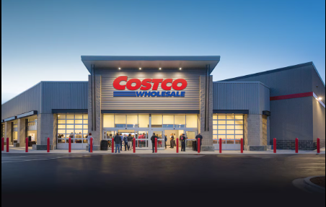

INTRODUCTION
Costco Wholesale founded in 1983, has emerged as a global retail giant. With its unique membership-based model and commitment to quality, Costco has become a household name. As a data scientist, I've designed and implemented a robust cloud-based architecture to enhance Costco's data-driven capabilities. In this project, I explore the intersection of data science, cloud computing, and software architecture.

OBJECTIVES
The primary objective of transforming Costco’s data infrastructure is to increase flexibility, particularly in handling peak shopping seasons and unexpected spikes in online orders. This is crucial for ensuring a seamless shopping experience for customers, regardless of demand fluctuations. Additionally, the initiative aims to improve performance, scalability, and cost optimization. By leveraging cloud services, Costco can optimize performance metrics, ensuring smooth operations even during high traffic.

CHALLENGES
One of the key challenges faced by Costco is balancing performance with cost-effectiveness, especially as the company expands globally and encounters seasonal demand fluctuations. Legacy systems have struggled to handle increased workloads, highlighting the need for a more robust and scalable solution.

VISION VISUALIZATION

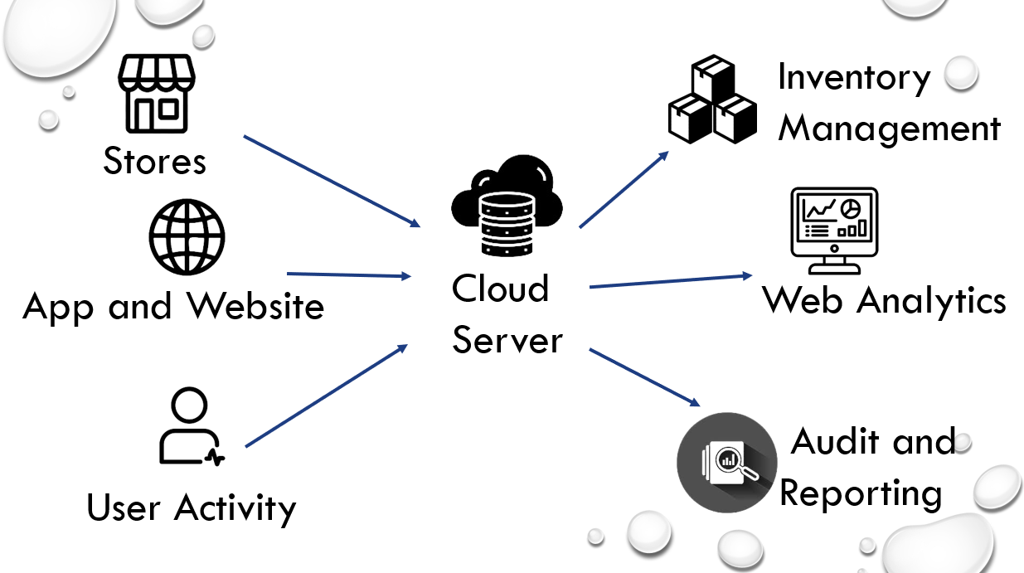

The project report emphasizes the vision for visualizing the transformation of Costco’s data infrastructure. Physical retail outlets are integral parts of many businesses and digital presence is vital for reaching a global audience. Whereas, e-commerce, apps and websites are always up-to-date with the latest data. So, all the data from these sources uploaded to the cloud server. Cloud servers offer automated solutions for tracking inventory levels, reordering stock, and optimizing supply chains. Efficient inventory management prevents overstocking or stockouts. Real-time data ensures that businesses stay agile and responsive. Identifying new audiences, trends and identifying new potential customers using customer data is web analytics also, Forecasting demand, propensity to purchase, and overall customer lifetime value.

PROPOSED CLOUD ARCHITECTURE

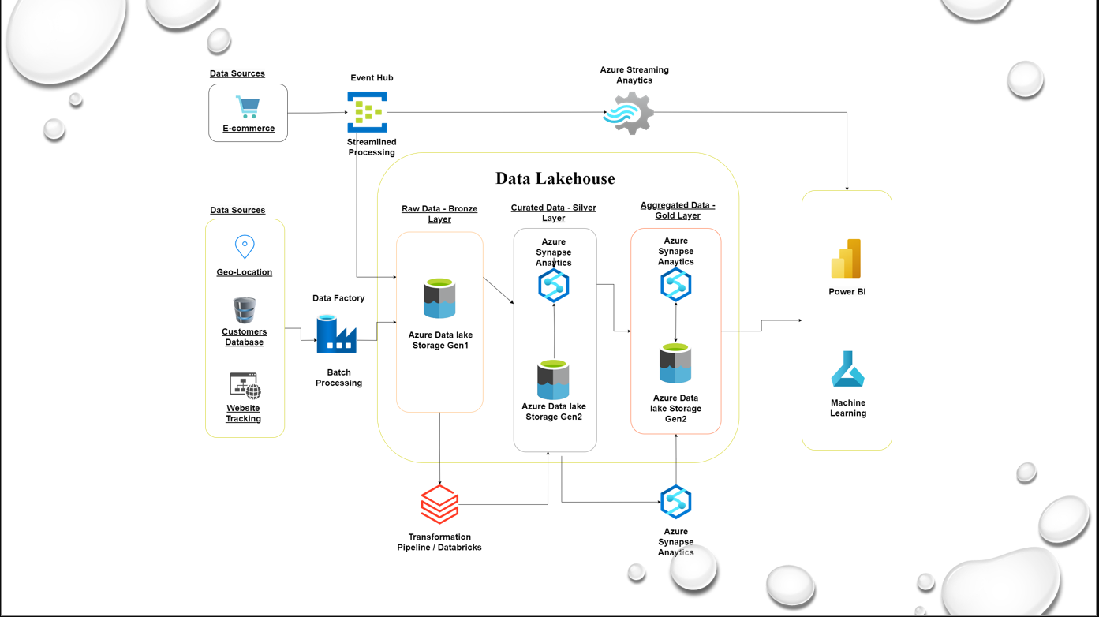

The journey begins with data sources from where the data is collected. These data sources are geo locations(stores), customers database, website tracking and e-commerce. In the second stage the data in native form is ingested to the data lake house’s bronze layer through Azure data factory. Azure Data Factory is managed cloud service that is built for these complex hybrid extract-transform-load to data lake house. It is batch processing in which data is collected from sources (stores, customer database, website tracking) and ingested to data lake house. whereas data is collected from e-commerce and used for streaming by Azure streaming analytics and visuals directly stream by power BI. To handle the influx of real-time data, we introduce the Event Hub. This component acts as a gateway, ensuring that large volumes of fast-streaming data are processed efficiently. In the bronze layer, data is stored in Azure data lake storage gen 1 in raw form. To refine our raw data enters the transformation pipeline, powered by data bricks and then pushed into curated layer. For the storage purpose, azure synapse analytics built inside the gold layer and for analytics it is setup outside data lake house. At the end, for visualization, power BI is used.

PIPELINE
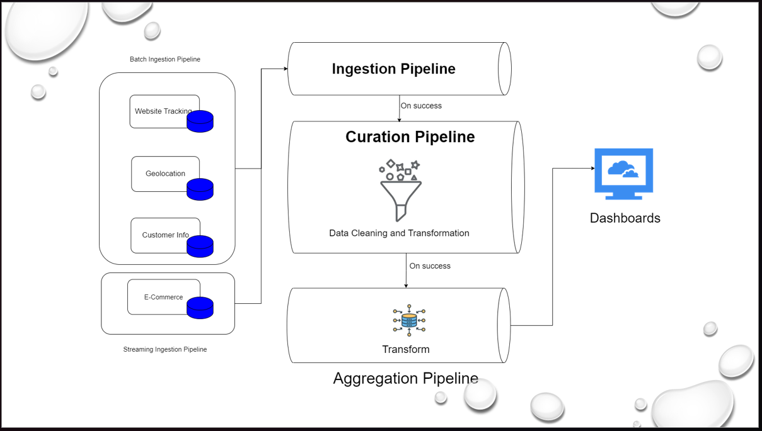
A data pipeline is a sequence of interconnected data processing stages. Data is ingested from sources to the ingestion pipeline via batch processing and streaming. it is an initial stage where raw data enters into the system. After ingestion, data needs cleaning and transformation which is done in curation pipeline. Only high quality and relevant data is transformed to next pipeline that is aggregation pipeline. Its purpose is to transforming data elements into aggregated results. Then, fine type of data is feed into dashboard for data analysis and visualization.
DATA PIPELINE AND DEPLOYMENT STRATEGY
The data pipeline encompasses batch ingestion, data cleaning and transformation, aggregation and analysis which enables the company to manage and analyze its data effectively. Whereas the deployment strategy includes content delivery, containerization and ensuring the data deliver effectively to users.
Conclusion
Costco’s initiative to transform from legacy system to cloud architecture will be significant step towards enhancing performance and flexibility as a company evolves in a dynamic retail landscape.

Reference
https://www.simplilearn.com/azure-architecture-explained-article#:~:text=What%20are%20the%20key%20elements,management%2C%20security%2C%20and%20monitoring.
https://cloud.google.com/discover/what-is-cloud-analytics#:~:text=Cloud%20analytics%20helps%20to%20enable,for%20customers%2C%20employees%2C%20and%20vendors
https://learn.microsoft.com/en-us/azure/data-factory/introduction
https://distributedsystemsauthority.com/postgresql-high-performance-guide-architecture/
https://d3.harvard.edu/platform-rctom/submission/costco-creating-membership-value-in-a-digital-world/
https://cloud.google.com/discover/what-is-a-data-lakehouse#section-4

